1. 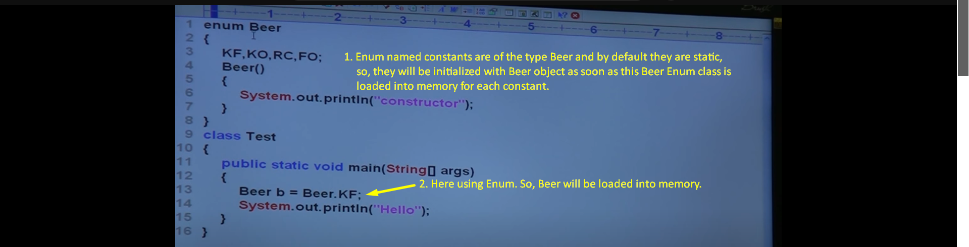  
     
   
2. If we comment the following line.  
     
     
   
3. Why we can not this?  
   Beer b = new Beer();  
     
   **Answer**: We can not create. Compile time error. Better go for Class then.  
   
4. Abstract method inside enum class not allowed as enum class by default is final. We can not create its child class.   
   If any abstract method, then the class/enum must be declared as abstract but the enum class is final 😊 Loop.
5. 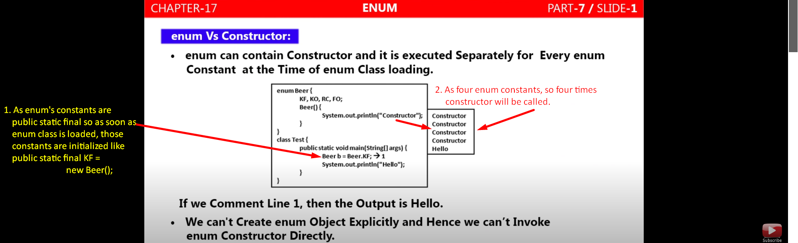
6.   
     
   